By 1068664

Design For The Internet
EJ115004S

Contents
Asset List 2
Wireframe 3
Moodboard 4
Client Website Spec 5
Sitemap 6
Sitemap description 7
Personal Learning Perspective 8
Sample screenshots 9

Asset List
File Name & Type | Size | Where Used | Save Location
ajax-loading.gif (31x31) | 2.54kb | anxiety.htm  bipolar.htm  dst.htm  glossary.htm  links.htm  ocd.htm  unipolar.htm | /images
anxiety.jpg (250x299) | 18.4kb | anxiety.htm | /images
bds.jpg (403x403) | 44.9kb | bipolar.htm | /images
black-70.png (50x50) | 166b | anxiety.htm  bipolar.htm  dst.htm  glossary.htm  links.htm  ocd.htm  unipolar.htm | /images
ocdcyclepattern.jpg (640x384) | 20.8kb | ocd.htm | /images
unipolar.jpg (400x343) | 25.2kb | unipolar.htm | /images
tt_bottom.gif (400x5) | 94b | anxiety.htm  bipolar.htm  ocd.htm  unipolar.htm | /images
tt_left.gif (5x150) | 73b | anxiety.htm  bipolar.htm  ocd.htm  unipolar.htm | /images
tt_top.gif (400x5) | 93b | anxiety.htm  bipolar.htm  ocd.htm  unipolar.htm | /images

Wireframe
32px
1080px
MENU

Height is set to auto to account for the content of the div

CONTENT

1060px

FOOTER
32px
1080px

Moodboard
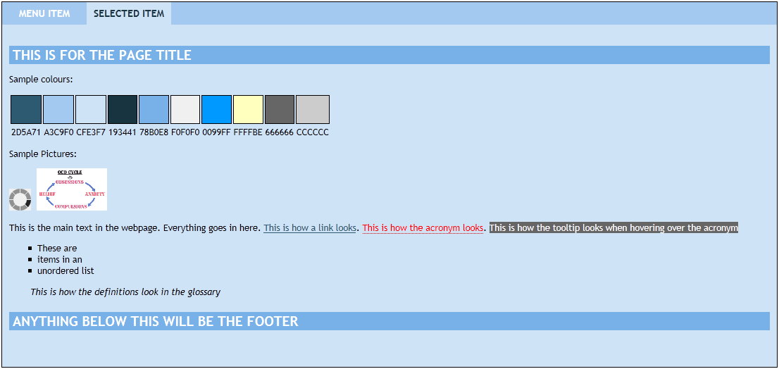

Client Website Spec

The purpose of this site is intended to be an informational point of reference for information on mental health and causes/symptoms/remedies.

The intended audience of the site is anyone wanting information on mental health.

The client is a mental health organisation specialising in, and wanting to show and share, information on mental health.

The site itself is intended to be an informative site.

The client wants to offer information about mental health and be a place of reference for people to get this information. They want the site to be available to all age ranges and they don’t want to exclude anyone. They want the site to be light and bright. They would like blue colours on the site.

The site is intended to be a formal informative site

Sitemap
whatismh.htm
index.htm
glossary.htm

contact.htm
links.htm

whogetsmh.htm
mhstats.htm

conditions.htm
howgetmh.htm
stigma.htm

anxiety.htm

ocd.htm

bipolar.htm
dst.htm
unipolar.htm

Sitemap Description
index.htm – This is the homepage and contains a description of the site and a link to the contact form

contact.htm – This is a way for the user to contact the site

whatismh.htm – This page describes what mental health is and what it means

whogetsmh.htm – This page describes who may suffer with mental health issues

howgetmh.htm – This page describes how mental health issues may arise in a person’s life

conditions.htm – This page provides links to 4 common mental health issues (anxiety, bipolar, ocd, unipolar)

anxiety.htm – This page describes what anxiety is, how it surfaces, how it is treated and videos about anxiety. It also provides a link to a depression self-test

bipolar.htm – This page describes what bipolar disorder is, how it surfaces, how it is treated and videos about bipolar disorder. It also provides a link to a depression self-test

ocd.htm – This page describes what OCD is, how it surfaces, how it is treated and videos about OCD

unipolar.htm – This page describes what unipolar disorder is, how it surfaces, how it is treated and videos about unipolar disorder

dst.htm – This page provides a standard depression self-test with a scoring system. Includes disclaimer that it does not substitute medical advice

stigma.htm – This page describes what stigmas mental health sufferers may encounter

mhstats.htm – This page provides some mental health statistics

links.htm – This page provides external links to some mental health charities and organisations

glossary.htm – This page provides a list of terms used throughout the site and a definition of those terms.

Personal Learning Perspective

While studying this unit, it has led me to overhaul my knowledge of HTML, CSS and java script.

While building the website, I have been able to question my knowledge of HTML, CSS and java script.

It has allowed me to identify what knowledge is out of date and what knowledge is current.

Where I have identified out of date knowledge, I have been able to replace that with the most up to date knowledge through studying the Design for the Internet semester.

I have been able to learn and understand the importance of building websites and web pages that are cross compatible with different browsers, different systems and different screen resolutions. I have been able to put this knowledge into action during this semester.

During this semester, I have learnt how div tags in web pages play a pivotal role and this is one example of where my HTML has been overhauled. Before this semester began, where I needed a div tag I would use a table tag instead. This course has allowed me to replace my knowledge of the table tag with knowledge of the div tag.

Before this semester started, I wasn’t fully aware of the HTML doctypes and the correct grammar and syntax of coding in HTML. This semester has shown me the importance of doing so.

I have also seen the importance of being able to provide a website that is valid in HTML grammar and syntax, and how that allows a web page to be cross compatible.

I have also learnt more about CSS coding and stylesheeting. I have learned how to add CSS in an external stylesheet and to reference it from within the web page. I have also learned the difference between inline, external, and embedded styling and where these would be appropriate in the web page itself.

Before this semester started, my stylesheeting was somewhat limited to text decorating and this was mainly done either inline or embedded. I have been able to research cascading style sheets and all the various options that it provides. I have been able to overhaul and increase this knowledge to make the website look pleasing to the user and client. I have learnt how to use the different options to change the layout, colours and text of the web pages.

Perhaps the biggest knowledge overhaul and increase is with Java script. As I have been left to research java script, it has enabled me to look at various examples and study how they work together. From that studying, I have been able to put different bits of java script together. After putting the scripts together, I have been able to incorporate those scripts within the web pages to enhance the user experience of the website.

I have learnt how to validate a user submitted web form, show a tool tip over the acronym tag and to show or hide div elements using java script.
Screenshots

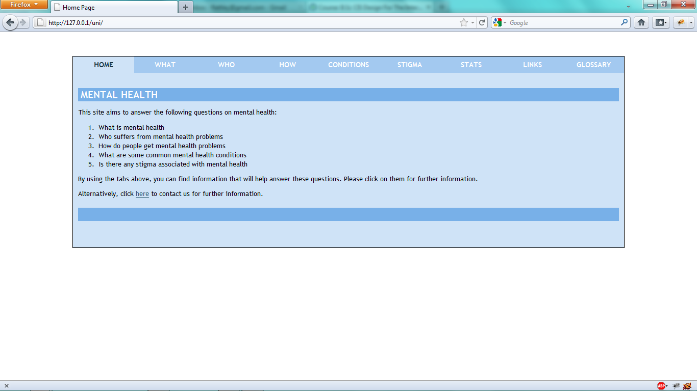

Index page

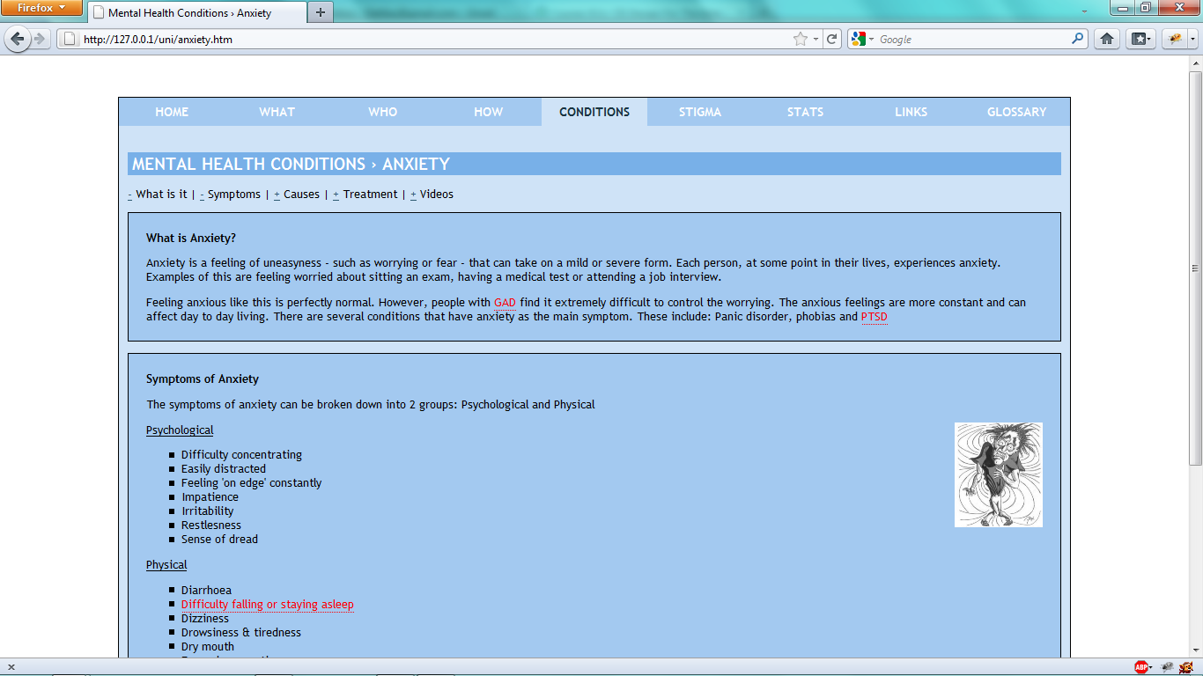

Anxiety div example

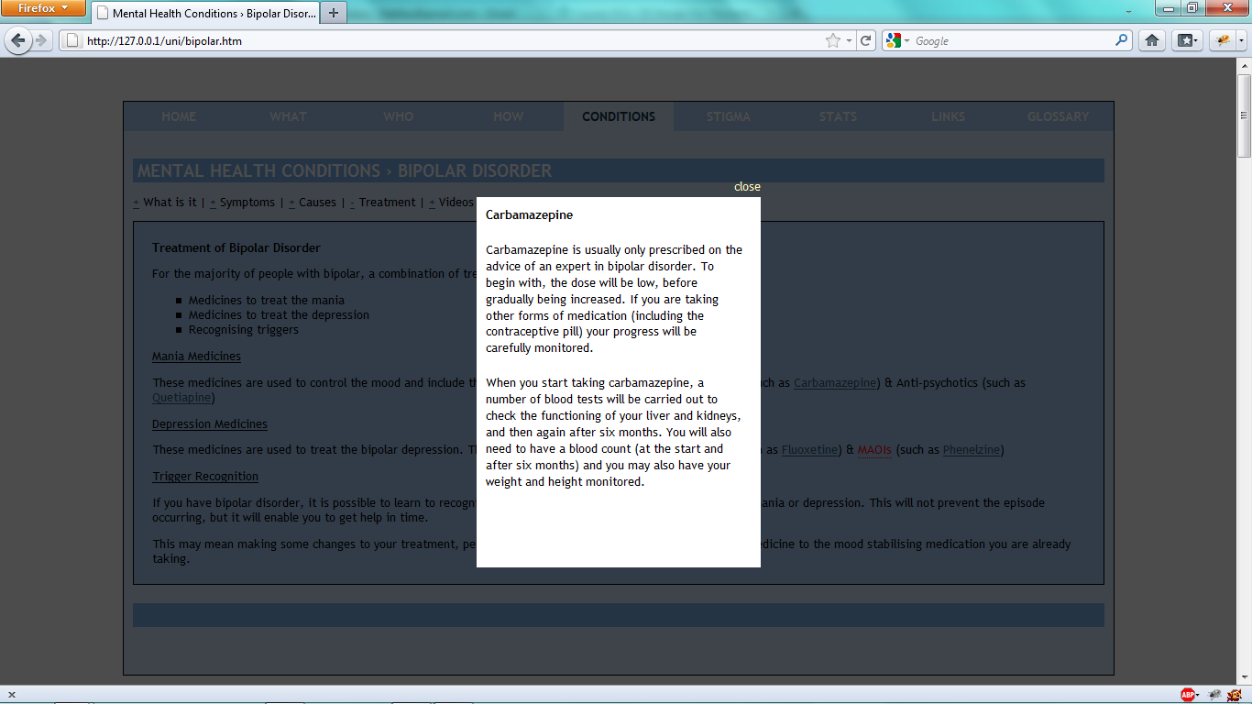

Bipolar treatment medicine information in a light window

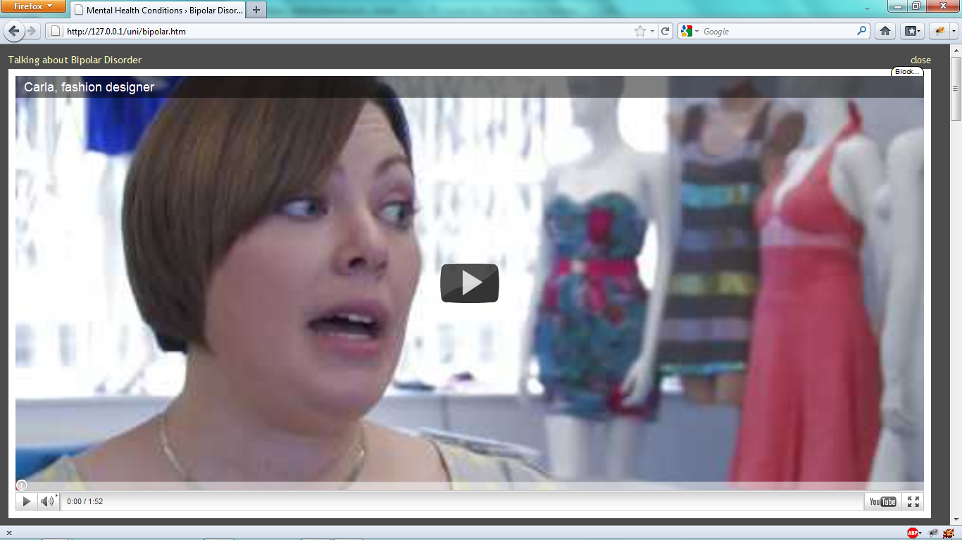

Bipolar video in a light window

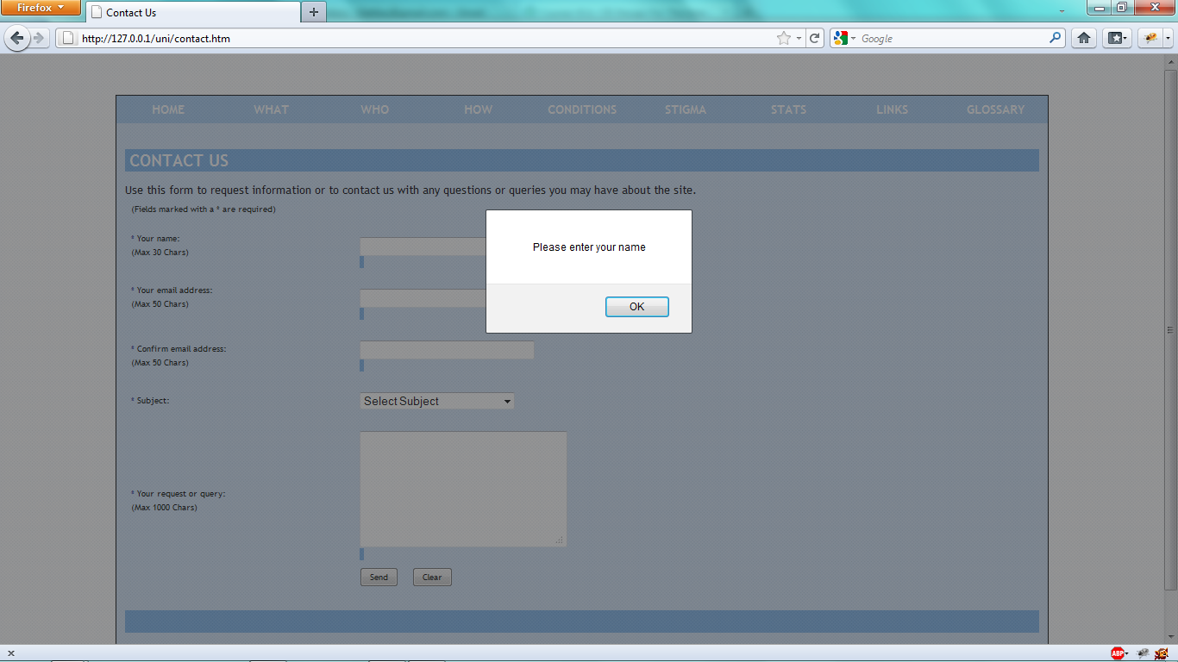

Contact form validation error alert box

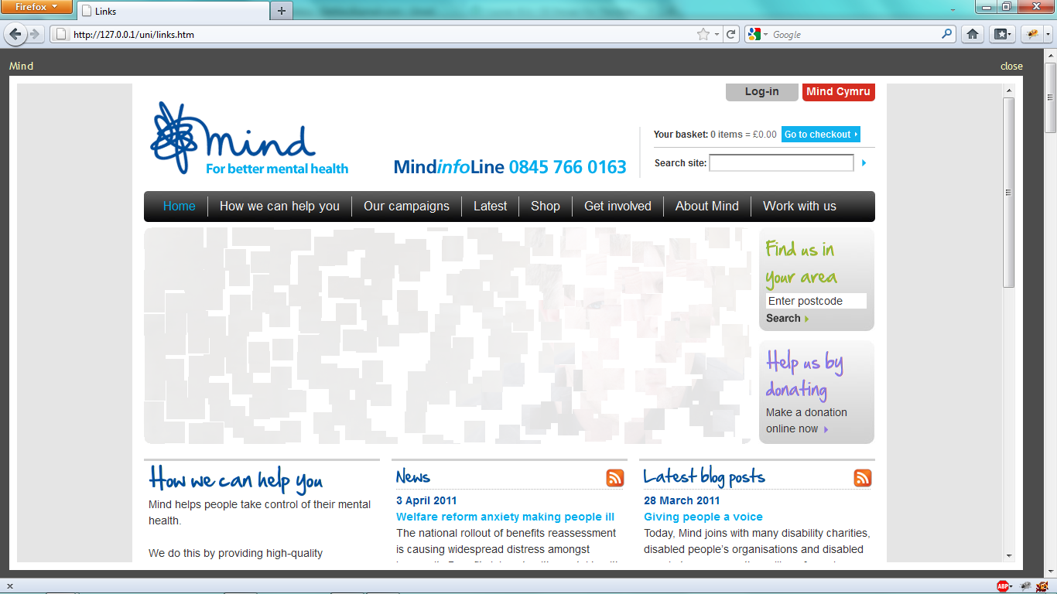

External link example in a light window

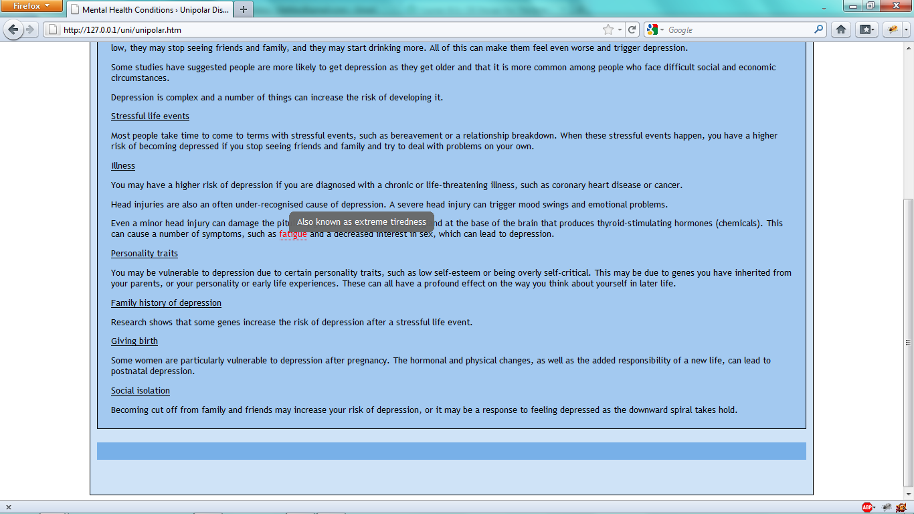

Java script tool tip example

