Final Year Report
Can technology be used to enhance the learning of numeracy in conjunction with the National Curriculum?
1068664 - 2013 | BSc (Hons) Computing and Information Systems Anglia Ruskin University | MOD002691

Table of Contents
Project Declaration 3
Abstract 3
Acknowledgements 3
List of Figures 4
Introduction 5
Background 5
Motivation 5
Research Aim and Objectives 6
Learning 6
Methodology 7
Research Methodology 7
E-Learning 13
Development methodology 15
Classic Waterfall 15
Incremental Waterfall 16
Spiral 16
Design 18
Questionnaire 18
Question Ordering 18
Coding 19
JSON v XML 19
HTML5 v Flash 22
jQuery v MySQL/PHP 24
Images v Plain Text Questions 25
Artefact 26
Interface Design 26
Usability 27
Feedback 29
Project Management 31
Risk analysis and mitigation 31
Risk 1: Illness 31
Risk 2: Equipment Failure 31
Risk 3: Data Loss 32
Risk 4: Inability to Complete Artefact 32
Risk 5: Inability to Access Artefact Online 32
Implementation 33
Focus Group 1 33
Artefact Testing 34
Artefact Build 34
Iteration 1 34
Iteration 2 35
Iteration 3 35
Iteration 4 36
Iteration 5 36
Iteration 6 37
Iteration 7 37
Results of Artefact Testing 40
Analysis of Results 40
Conclusion 47
Success on initial objectives. 47
What did or did not go well? 48
Tools used 49
Achievements 49
Future developments 50
Drag and drop questions 50
Certificate of completion 50
Image maps 50
Login system 51
Staggered star progression 51
Sounds as feedback 51
Question Banks 51
Appendix 1 – Initial Gantt Chart 52
Appendix 2 – Actual Gantt Chart 55
Appendix 3 – Interview with Primary School Teacher 58
Appendix 4 – Artefact Design Questionnaire 62
Appendix 5 – Artefact Design Questionnaire Results 66
Appendix 6 – Artefact Testing Questionnaire 73
Appendix 7 – Wireframes 76
Appendix 8 – Minutes of Supervisor Meetings 78
Appendix 9 - Poster 81
Bibliography 82
References 85

Project Declaration

Can technology in the home be used to enhance the learning of numeracy, in conjunction with the National Curriculum?

Abstract
The report and associated artefact set out to determine if a technological game can enhance a 7 – 9 year old child to learn numeracy skills. This was done as the numeracy levels in the local area are not in line with national curriculum guidelines.
The artefact was developed to enable the child to learn numeracy in a fun and engaging way – whilst keeping it line with the national curriculum and making it as real life as possible.
The results from the testing of the artefact showed that the child was engaged in the learning without realising that it was effectively a maths lesson. The results also showed that some children wished they had this available to them in school.
The significance of this shows that making learning practical, fun and as engaging as possible will enable the child to improve their numeracy skills without feeling like they are in a classroom.

Acknowledgements

Jamie Myland and Chris Jakeman for being project supervisors and providing guidance where needed.

Jamie Wilcox, Emma Wade, Liz Hunt and Lyana Klymyuk Watson for testing and providing feedback on the artefact.

Jo Mills and Carrie Henderson for providing information to enable the artefact to include national curriculum standards. Also for providing information on what maths skills are taught in the classroom.

Matt Jones, Sadie Cooper, Kayleigh Allsopp and Sophie Russell for providing feedback prior to, and during the artefact building stages.

Jamie Wilcox and Allan Slade for proofreading the report and informing of changes that needed to be made.

List of Figures
Figure 1 - Quiz from Woodlands Junior School 8
Figure 2 - Quiz from BBC Schools 9
Figure 3 - Quiz from BBC Schools 9
Figures 4 and 5 - Feedback from BBC Schools quiz 9
Figure 6 - Quiz from InQuizitor 10
Figure 7 - Feedback from InQuizitor quiz 11
Figure 8 - Visual feedback from InQuizitor quiz 11
Figure 9 - End of game feedback from InQuizitor quiz 12
Figure 10 - Second iteration of artefact 35
Figure 11 - Fourth iteration of artefact with a visual representation of scores 36
Figure 12 - Sixth iteration of artefact showing score achieved and potential score 37
Figure 13 - Final iteration of artefact showing clickable image instead of buttons 39
Figure 14 - Final iteration asking user to work out the password and then where they can enter it 40

Introduction

Background

During the summer of 2012, an opportunity arose to spend time with two 7-8 year old children. During this time, an opportunity had arisen to help with numeracy and literacy work to prepare them for going back to school.

The alarming part is that the children were fairly unfamiliar with the multiplication part of numeracy – being able to only recite the ‘1’,’2’, ‘5’ and ‘10’ multiplication tables and struggling somewhat with the ‘3’ multiplication table. They also struggled with what could be termed as basic numeracy – these are questions such as ‘10 + 10’ or ‘what is 50% of 12’.

Motivation

During an initial sweep of the internet, library and various other learning tools, it appears that there is very little in terms of quizzes and games that offer any way to help children learn mathematical problems. Of the quizzes and games out there, none of them offer any kind of real life scenario mathematical problems. They offer basic numeracy sums – albeit with some interactivity. These can be found in the Research Methodology section.

This project aims to bridge the gap between numeracy problems and putting them into real life situations. The project and artefact will be of interest as it exposes, and tries to help, the lack of numerical skills instilled in the 7-9 year olds. The project also talks about e-learning and how that is of benefit to help in learning basic numeracy skills.

Research Aim and Objectives

To identify whether a game that is used at home will help the child to learn numeracy skills.

To identify specific numeracy learning methods that are taught in schools in the UK.

To identify the way in which children learn – specifically, do colours and shapes enhance learning.

The overall aim of the project is to determine whether simple maths problems can be solved and learned through the use of the attached artefact. The artefact will contain real life examples of simple maths problems – for example: ‘You and 3 friends decide to get the bus to school; the fare is 5p per child, how much do you need to give the driver?’

Learning

Along with the research aims and objectives, the project and artefact are aiming to help develop skills in project researching and artefact building.

The research skills the project are aiming to develop are that of finding material related to the project, and the ability of being able to determine whether it is useful to the project. It is also hoped that once this information is determined to be of use to the project, the ability to critically evaluate the information will be achieved

The skills the artefact is aiming to develop are that of jQuery, JSON, JavaScript and HTML. It is hoped that these skills will be developed while building the artefact.

The aims of the learning can only be determined once the project and artefact are finished.

Methodology

Research Methodology

For the literature review, it has been decided that the University e-Library will be used to search several large databases that contain books, websites, articles, journals and newsletters.

A decision has been made that a search of these databases needs to be performed on certain keywords. Once there are results from these keywords, a scan of the abstract will be made to determine whether or not it is appropriate for the project. If it is not appropriate, it will be disregarded. If it is appropriate, key phrases will be highlighted. In addition to this, a general sweep of what games are available within the scope of this document will be made.

Several sources were found that contained games, but none met the requirements of this document.

One of the websites that was looked at was that of Woodlands Junior School in Kent. The site itself contains a number of games. These appear to be the same game, just modified for the type of numeracy presented. The addition game consists of a number of addition questions and this format is then used for subtraction, multiplication and division. There is nothing to distinguish the various games from one another.

Another example of a game they have, is a game with questions and a missing part. You have to select the correct answer from the dropdown menu. This is, again, in the same format used for the different branches of basic arithmetic. This is also the format used for the ‘IQ Maths’ pages that they have on their website.

While this may be of use to those children who are able to learn without visual aids, it does not address the issue of making learning fun.

The dropdown contains the answer. It is not very imaginative or attention grabbing
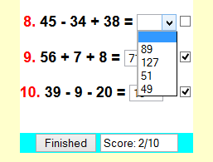
The score box does not provide anything of value. A score is worthless without any feedback
Checkboxes do not provide an imaginative way to let the user know they are right
Figure 1 - Quiz from Woodlands Junior School

Woodlands Junior School have called this ‘interactive maths’. It is thought that this is a misnomer, as it isn’t interactive in any way other than a click of a button to tell you your score.

This artefact aims to conquer that. Although the user will click a button to get to the end of the quiz, it will provide feedback as to what was right and what was wrong. It will provide the user a way of knowing where they have gone wrong and a way to get the question right in future attempts.

It also aims to provide the user with a click-through real life scenario. This will also grab their attention and make them want to continue.

As far as can be gleaned from Woodlands Junior School, their pages do not do that. The pages are, to a certain degree, dull in features.

Another site that has some activities for the age group of this project is BBC Schools. They have quite a few maths games for all age ranges of children. They have some specifically for the age range talked about in the report.

The games presented on the BBC site are generally interactive. These games will keep the attention of the children and will enable them to learn in a fun environment. One of the games they have is called Number Jumbler.

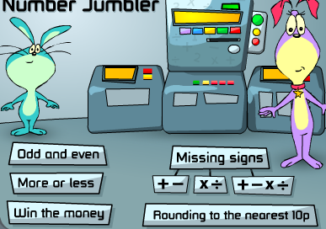
The user has a choice of game
The character stays with the user throughout the game
Figure 2 - Quiz from BBC Schools

The user receives very basic feedback
User receives feedback from here
The user has to choose the correct mathematical symbol
Figure 3 - Quiz from BBC Schools

Figures 4 and 5 - Feedback from BBC Schools quiz

As you can see, the feedback does not fall under what Geoff Petty would define as ‘good feedback’. This feedback only allows the user to know if they were right or wrong. It does not allow them to understand how the problem was wrong, and how it can be solved.

Another site out there for the project age range is InQuizitor. There are only 2 games in the Key Stage 2 maths group. The quizzes themselves are very interactive and will keep the users attention.

The game presents you with a question and some answers. The number of answers is dependent on the level that you are on. The greater the level is, the more the number of answers that are displayed.

This is a timed bar. Once this is exhausted, the question automatically gets marked as wrong
The question is presented along with the answers. The higher the level, the more answers there are
Figure 6 - Quiz from InQuizitor

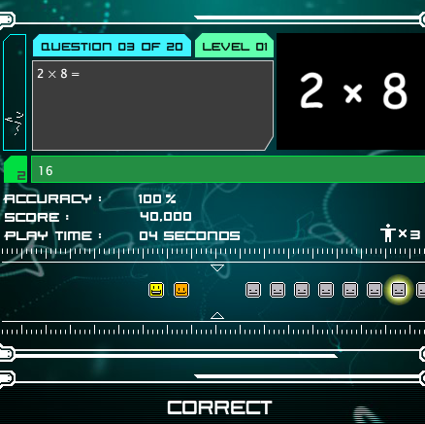
This shows the user how many lives they have. It makes it a real game concept
Shows which questions were right and which were wrong. The glowing face represents a sub game
This provides the user with statistics
Even if the question is wrong, the right answer is highlighted
Figure 7 - Feedback from InQuizitor quiz

The faces help the user to know which were right and which were wrong.
Figure 8 - Visual feedback from InQuizitor quiz

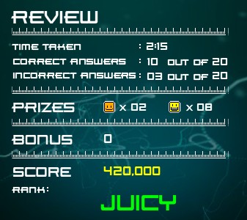
General feedback is provided to the user.
Figure 9 - End of game feedback from InQuizitor quiz

It is felt that the statistics after every question may not be needed, as they may serve as a distraction to the user. The user may not be of a level to interpret what the statistics mean. However, this feedback provides some insight into how well the user is doing – or not doing as the case may be.

It is felt that the artefact should take aspects of the BBC Schools games and also the InQuizitor games.

These aspects are namely:

- A mix of question types (in the case of the artefact, a mix of different arithmetic branches)
- Good and bad feedback in a positive way

E-Learning

The aim of this section is to determine whether or not the artefact for the project can be considered as an e-learning tool. The project will need to take into account whether the e-learning aspect can be considered as such. Also, what are the advantages and disadvantages of such an artefact in the sense of e-learning?

E-learning is defined as “…learning facilitated and supported through the use of information and communications technology…” (JISC, n.d.)

Based on the definition from JISC the artefact can be considered as an e-learning tool as it is providing the learning via information and communications technology.
1

E-learning has many advantages and, also, some disadvantages when compared with the traditional face to face learning in a classroom.

One such advantage of e-learning is that access to the study materials can be from wherever there is a computer and an internet connection.

In terms of the artefact in this project, the initial access will be from classrooms. However, that does not need to remain the case. The implementers of the artefact can choose to allow external access. This will enable the learners to be able to access the material from wherever they have a computer and internet connection.

Another advantage of e-learning is that it allows the learner to be able to learn at their own pace. Whilst this is a distinct advantage of e-learning, it can also be considered as a distinct disadvantage.

By allowing the user to work at their own pace, it also has the potential to foster a lack of motivation. It also removes the classroom structure and routine. This could serve to enable the user to fall behind to a pace that is inconsistent with the pace of learning.
However, as it is described as self-pacing, the user must be allowed to continue at a pace that is comfortable for them.

Another major advantage of e-learning is that it allows different learning styles to be accommodated. The artefact can draw on this advantage. The artefact can be implemented in a way that allows different learning styles to be incorporated, so as to not exclude any learner.

At the moment, the artefact is based purely on a visual learning style. However, it will not be difficult to amend it to incorporate the different learning styles. This will be something that is decided by the different institutions that would use the artefact.

E-learning also allows users to take responsibility for their own learning. While this may be the case for most users, the artefact is aimed at a group that is in the 7 – 9 age range. It is disadvantageous to require users of this age to take responsibility for their own learning.

Therefore, this otherwise major advantage may be seen as a disadvantage for this age range and for this artefact.

A disadvantage that is associated with e-learning is that of users with low motivation or bad study habits will fall behind. The only way this can be considered a disadvantage is if the artefact is built to a standard that is very dull and boring and does not engage the user in any way, shape or form.

The artefact will be designed and built in a way that will be engaging for the users and require their input at every level. This will allow the users to build up the motivation to continue and not fall into the supposed disadvantage aforementioned.

Several more disadvantages of e-learning are cited as:

- Isolation from instructor
- Instructor availability
- Poor technology
- Lack of social benefits of interacting with classmates

The artefact aims to overcome the first two disadvantages by implementing it in a classroom setting where the instructor will always be there.

The artefact is built using minimalist coding making it lightweight and able to stand the test of poor technology. As the artefact is not resource intensive, this will alleviate that problem almost entirely.

Development methodology

Several methodologies have been looked into for this project. The methodologies that were looked at were:

- Classic Waterfall
- Incremental Waterfall
- Spiral

Classic Waterfall

The Classic Waterfall methodology was looked at for this project and quickly ruled out. This model is very limited for this kind of project. This methodology does not allow for changes to be made during the process.

The idea of this model is that the requirements are signed off before any designs are made. This makes the requirements rigid and unable to be changed without having to start over again. The design can only take place once these requirements are signed off.

Once the design stage has been signed off, it presents that rigidity that was present in the requirements step. Any change in design has to go back to the requirements stage and be started all over again.

Designing by this method will add a significant amount of time to the overall project due the rigidity constraints provided in the requirements and design stages.

Incremental Waterfall

The Incremental Waterfall methodology was looked at as part of the development review. This version of the waterfall methodology provides a looser – as in terms of flexibility – approach to the design of the artefact.

This model allows for backtracking through the various stages. If the requirements change during the design process, this is fine. The new requirements can be incorporated for the next iteration.

This flexibility allows for the overall project time to be somewhat constant and not overrun as it would do using the aforementioned Classic Waterfall method.

Spiral

Another methodology looked at for the artefact was that of a Spiral Methodology. This methodology is based on the Classic Waterfall methodology. The difference is that risk management is built into this methodology.

This methodology also uses iterations, or rapid prototyping, as does the Incremental Waterfall method.
It has been decided, after looking at several methodologies, that the ‘Incremental Waterfall’ methodology is most appropriate for this project.

The Incremental Waterfall methodology was chosen as it is the standard methodology used in software development.

The reason the disregard of the Spiral method was that risks are being mitigated for. If there was not a way to mitigate for these risks, then the Spiral method would be the better methodology for this project.

The artefact is built using iterations. The first iteration is obviously the very basic form of the artefact.

As each new feature is added, it is given a version number and any changes that were made are documented. This is how each iteration will be performed.

The iteration will first start by looking at the requirements provided by the customer. The artefact will then be designed and built.

The artefact will then be presented to the customer to see if there are any other changes that need to be made. If further changes are needed, these will be documented and added to a list that will need to be incorporated in the next iteration. Iteration testing will be performed when every major change has taken place. The iterations will follow this format until it is fully signed off by the customer.

The iteration numbers and the changes can be found under the ‘Artefact Build’ section on page 34.

Design

Questionnaire

It was decided that a questionnaire should be compiled to try and get some input from parents of children in the 7-9 age bracket. This was deemed important as the children may use this from home and the most likely source of help while at home would be a parent.

It was also deemed necessary to involve parents in the design as they fundamentally know what engages their children and what can be used to keep them entertained and want to continue to learn.

The questionnaire is included in Appendix 4 to show the list of questions that were asked. The questionnaire wanted to gauge firstly, what level of maths the child was at. The questionnaire then centred on questions about the design. This was to determine what would, and wouldn’t be, considered useful.

The questionnaire wanted to know whether images, videos, sound bites or text questions were the most effective way of conveying a particular maths problem.

The questionnaire was abandoned as respondent uptake was not as anticipated. The results from the few respondents that did take part are included in Appendix 5

Question Ordering

Another aspect of the design that was considered was to whether ordered question and answers be allowed. It was decided to build in an option to allow the teacher or parent to decide if questions and answers should be inserted sequentially or randomly.

It was decided to include this option as there may be a need for both to occur. The questions may need to be sequential if they are based on what happens during a day. For example, the child gets up, goes to school, attends lessons, has play time, comes home, does things before bed and then goes to bed. Each of these activities could pose a question and they could be ordered in a way that imitates a real day.

From speaking with a teacher at a local primary school, this was thought to be of benefit so as to make the scenario as real life as possible. The minutes of this meeting can be found in Appendix 3

It was also decided that allowing the questions and answers to be randomly inserted would prevent the child from learning where they appear off by heart and being able to answer them without actually learning anything. As one of the aims of the project is to aid in learning, this was found to be an imperative option to have.

Coding

For this artefact it was decided that JSON, jQuery and HTML5 were the coding styles of choice. Various other options of coding the artefact were looked at but they were not deemed as the right choice for the artefact.

This section will detail why each coding language was chosen. It will also detail what other coding languages there were as options and talk about why they were not considered appropriate for this project.

JSON v XML

This section will detail some strengths and weaknesses of JSON and XML and why JSON was ultimately chosen as the data deliverer of choice.

One of the good things about JSON is that it is terse in the syntax that it uses. JSON integrates very well and very cleanly with most languages that are object-oriented. JSON itself is a literal representation of an object in an object-oriented language.
The syntax of JSON is very easy to use. It follows a notation that requires very little knowledge to be able to get it to work. The notation is set up as an object, an array, a value, a string or a number. All that is requires is that it has a name and value pair and has an ordered list of values.
It is this simplicity that allows it to be interchangeable between programming languages.

A simple data construct in JSON is as follows (This is based on the artefact):

var quizJSON = {
“questions”: [
{
“t”: “img”,
“i”: “image data”,
“ie”: “used for IE browser detection to enable the right representation to be used”,
“moz”: “used for WebKit browser detection to enable the right representation to be shown”,
“q”: “The actual question”,
“a”: [
{“option”: “answer representation”, “correct”: “false”},
… repeated depending on the number of answers required],
“correct”: “Feedback based on a correct response”,“incorrect”: “Feedback based on an incorrect response”
], … repeated depending on the number of questions
}
As you can see from the example above, the notation is very terse and follows a pattern.

JSON also has the following additional benefits:

- It's simultaneously human- and machine-readable format;
- It has support for Unicode, allowing almost any information in any human language to be communicated;
- The self-documenting format that describes structure and field names as well as specific values;
- The strict syntax and parsing requirements that allow the necessary parsing algorithms to remain simple, efficient, and consistent;
- The ability to represent the most general computer science data structures: records, lists and trees. (Marinescu & Tilkov, 2006)

While JSON is perfect for this artefact based on the above descriptions, it does have its drawbacks against XML.

“… XML has a more complex structure than JSON, and this is both a weakness and an asset…

… In XML, you can add a child element or an attribute to anything you want…

… In JSON however, extension is not so easy. How do I extend a given JSON object with new data? I can add a new property (assuming it doesn't clash with a current or future one), but extending a given property is harder. If JSON property value is a number, how do I add more information?

You can certainly choose to make every property value an object, so that new properties can be added anywhere, but as soon as you do this, most of the simplicity of JSON is gone.” (metajack, 2010)

XML has the benefit that it allows you to introduce your own tags to store the data. It is not actually a DOING language. It is a structure, store and transport language.

The markup of XML is as follows:

<note>
<to>Tove</to>
<from>Jani</from>
<heading>Reminder</heading>
<body>Don't forget me this weekend!</body>
</note>

While the markup tags can be user generated, it is very strict. Opening tags must have a matching closing tag in the correct order, otherwise XML does not parse properly. Also, if there isn’t both an element and an attribute, this too will cause XML to be unable to parse properly and result in a page error.

In order for a naked XML file to be able to be human readable, a stylesheet is necessary. This stylesheet applies styling attributes to the user generated tags to allow the data to be displayed.

HTML5 v Flash

“…Flash fans also argue that, with 99% of browsers supporting the technology, they have a much larger audience reach. In addition, since all of the Flash “code” is compiled into a SWF file, someone looking to view the source would have to crack two levels of encryption to get what they need, a fact that many developers appreciate. Plus, because it’s owned by a single company, they (Adobe) have entire control on the technology’s innovation rate…

…HTML5 advocates argue that several of the things Flash fans see as pros are actually major drawbacks. Because the technology is driven by one company, they and they alone determine the future direction of Flash. Because the specification for HTML is developed by an open standards development consortium, they rely on feedback, allowing developers to shape the future growth of HTML…

“…Finally, while Flash can boast more current browser support, HTML5 is rapidly gaining in the adoption of its respective features. Almost all modern browsers include support for HTML5, not to mention tablets and mobile phones (many of which are not capable of running Flash at all).“ (Casale, 2012)

As you can see from the above quotes, it appears that Flash and HTML both have their advocates. One of the main advantages of using HTML5 over Flash is that mobile devices support HTML5 over Flash – in fact, many smartphones and tablets (namely Apple) do not support Flash at all.

For the artefact to be available to as wide an audience as possible and to as wide a medium as possible, Flash cannot be considered as a viable option. HTML5 is the only suitable alternative to Flash.

HTML5 has a viable place in the online market. YouTube has switched from Flash only playback to allowing videos to be viewed through the new HTML5 video tag. This uptake happened in 2011. If a web giant such as Google can provide HTML5 support, then it simply must not be discounted as a coding option.

HTML5 is carrying on from where HTML4 left off and has also introduced some new tags that make it easier to use video and audio.

This makes it a lot simpler to add audio and video in the form a questions. The coding required has gone from using the following 6 lines in the box below

<object width="" height="">
<param name="allowFullScreen" value=""/>
<param name="wmode" value=""/>
<param name="movie" value=""/>
<embed src="" width="" height="" allowFullScreen="" type="" wmode=""/>
</object>

To simply the three lines in the box below.

<video width="" height="" controls=””>
<source src="" type="">
</video>

As you can see, HTML5 has condensed the video code into 2 tags instead of the old 5 tag method. This is as a result of having open standards and a community to shape the way HTML5 moves forward. As Flash is proprietary, you will need to be defined by the standards set by Adobe.

While Flash is more widely implemented, it only moves forward as fast as Adobe allows. Should Flash become outdated, you would need to update the game to meet the needs of the current standard. As HTML5 is a text based code, it is easier to maintain and update as the online trend takes shape.

jQuery v MySQL/PHP

It was decided that jQuery was the language of choice for this project. This was in part down to the reason that PHP/MySQL requires a webserver and if this were to run on a home computer, the chances that a web server would not be present on a home computer is very high.

If PHP and MySQL were to be used and there was no server present, it would render the game unplayable and thus make it redundant.

jQuery eliminates the need for a web server to be running and can thus be used on any PC that has a web browser. jQuery can run on any browser that can run JavaScript. One of the main problems that will be run into is if JavaScript is switched off in the browser. This can be overcome by displaying a no script message that details how to turn on JavaScript so that the game can be used.

As the game does not require an active internet connection, there is no risk to any form of harmful software being downloaded that would pose a risk to the uptake of the game. It would not spoil the user experience.

While jQuery can interact with PHP and MySQL, it is not in the scope of the artefact that it does so. This is reserved for future development of the artefact.

PHP and MySQL can play a pivotal role in the artefact – which will be mentioned in the future development section of the report.

Images v Plain Text Questions

This will be tackled in the form of a focus group. A focus group will be created to gather feedback on the types of questions that will be presented to the user. (Please refer section that talks about focus group one which can be found on page 33).

Also, the addition of colours or shapes in the questions will be the subject of a focus group. As shapes and colours play an important role in how children learn, it is important to know whether these are equally as important or whether one is more important than the other.

As colour blindness is something that some children may struggle with, it is important that these children are not excluded from participating in the game. It is important to offer a colour blind alternative for these children. This will primarily be done in the form of shapes and grey-scaling of the colours.

The questionnaire had 2 questions regarding this. It was important to glean what parents and teachers thought were important. This questionnaire can be found in Appendix 4.

There is little point in designing an artefact purely based on colours or shapes without knowing what is important.

The artefact will incorporate a stylesheet that transforms the bright colours into greyscale colours for those that are affected with colour blindness.

Artefact

When designing the artefact, it was important to tackle usability and UI [User Interface]. It was also important to make sure that the artefact conformed to some ‘best-practice’ guidelines. These guidelines were taken from Ben Schneiderman (n.d) and Jakob Nielsen (2012).

The reason these two names were chosen is that they are well known in their respected fields for their views on usability and UI.

Wireframes were produced to provide a way to preliminary see what the artefact would look like. These can be found in Appendix 7.

Interface Design

For the usability side of the artefact, Ben Schneiderman (n.d) has produced a list of what he calls the ‘Eight Golden Rules of Interface Design’.

The artefact itself will not follow all eight rules, as some of the golden rules are not pertinent to the artefact itself.

The main rule that is pertinent to the artefact is that of rule number one. This rule states “…Consistent sequences of actions should be required in similar situations; identical terminology should be used in prompts, menus, and help screens; and consistent commands should be employed throughout…” (Nielsen, 2012)

The artefact has followed this rule throughout the quiz. The buttons, in particular, are all uniform and this allows the user to know where they are to click. The layout of the questions are the same throughout. It was decided that having different question layouts would only serve to confuse the user. It was felt this would lead to inconsistencies within the quiz itself and perhaps the user would stray away from the quiz as it would lead to confusion.

The artefact is not designed to be something that is used repetitively and, therefore, offering some kind of shortcut to the user would serve no practical purpose.

The artefact is designed to enhance learning and providing a shortcut or a way to get around the quiz would only serve as a hindrance to the learning of the user. It is felt that this rule is of no value to this artefact.

Another of Schneiderman’s (n.d) golden rules is that of feedback. He comes at it from a point of view of feedback from the artefact to the user.

The artefact itself does contain an alert to let the user know that they need to select an option, and this does conform to his rule number 5 – in that it offers a way to handle the error of the user not selecting an answer while trying to move on to the next question.
In terms of the artefact, it has taken on a different meaning of feedback, one that follows Geoff Petty (2004) and his ideas on feedback (Please see page 29)

It was decided that his other golden rules were not pertinent to the artefact.

Usability

For the usability side of the artefact, Jakob Nielsen (2012) has written an article entitled ‘Usability 101: Introduction to Usability’ He starts out with defining what usability is, and why it is important.

It is felt that usability will play a vital role in the development of the artefact. If the artefact itself is not usable, it will be of no value to the target audience. The audience will, in turn, not be able to use it, therefore rendering the artefact redundant.

Nielsen (2012) talks about 5 quality components that usability must have. For this artefact, not all 5 quality components are thought to be necessary and therefore they will not all be included.

The first quality he talks about is that of learnability. It is important for the artefact that the user can accomplish the tasks presented to them from the very first time they encounter the artefact.

His next quality is that of efficiency. This in one of the qualities that the artefact will not take into account. It is not beneficial to the user to be able to just go through the questions on a rote basis. For the purpose of a quiz it is not efficiency that will get the users to the next level, it is how many answers they get correct that will enable that progression.

It is for this reason, that efficiency will only have a negative influence on the artefact and therefore it can only be seen as a negative quality to have in the artefact.

His quality of memorability is to be considered an important one. It is important for the artefact that once it has been left for an extended period of time by the user, they are able to use it just as if they had been constantly using it.

It is extremely important that the user feels comfortable with the artefact and therefore the design has to be to their satisfaction. A survey was carried out to determine what should be included in the design of the artefact and the results of this can be found in Appendix 5.

Jakob Nielsen (2012) goes on to say: “…There are many other important quality attributes. A key one is utility, which refers to the design's functionality: Does it do what users need?

Usability and utility are equally important and together determine whether something is useful: It matters little that something is easy if it's not what you want. It's also no good if the system can hypothetically do what you want, but you can't make it happen because the user interface is too difficult. To study a design's utility, you can use the same user research methods that improve usability…” (Nielsen, 2012)

The artefact itself started out as a simple web page with some text and some buttons. The user was then presented with the levels depending on which button they clicked.

Feedback

Geoff Petty (2004) states that feedback is a topic which is rarely done well. He states that feedback should include the following:

- Medals
- Missions
- Clear Goals

The artefact will aim to follow some of these principles, alongside those suggested by a Primary School teacher that has first-hand knowledge of how children learn.

Whilst Geoff Petty (2004) states that clear goals need to be given, this is not necessarily the case for a project of this type. The very fact that there are questions with maths based problems should be enough of a goal for the children. It is evident from the artefact that, in order to progress, questions need to be answered and, they have to be answered correctly.

It is understandable that clear goals are needed for some types of projects as the requirements may not be evident just from browsing the project.

It is felt that the artefact does not fit into this criteria – although, it has one line mentioning what the user has to do. The line itself is succinct and does not need any further explanation of the goals, or need any lengthy goals as is suggested by Petty (2004).

It is agreed that the artefact does need to follow the medals and missions aspect of feedback as described by Geoff Petty (2004).

Feedback is something that is seen as vitally important to learning. If this is not done in a correct manner, it can undermine the learner and turn them away from wanting to learn and in turn they will turn away from the artefact.

He states that “…Medals: This is information about what a student has done well, e.g. 'Your paragraphs and punctuation are good'…” (Petty, 2004)

It is felt that Petty is correct in his section on medals. It is important to provide the learner with feedback on what has been done well. If the learner is not sure of what they have done well, they will never be able to understand what it is they are asked to learn.

It is impossible to expect a learner to know what was right and what was wrong without some kind of system in place to provide that information for them.

In this case, the learner must be treated as someone who is answering questions only.

He also states that “…Missions: This is information about what the student needs to improve, correct, or work on. It is best when it is forward looking and positive…” (Petty, 2004)

It is vitally important for the learner to understand where they went wrong. Petty has this absolutely correct. If the learner does now know what was wrong, how can they be expected to improve and advance!

It is impossible and imperatively wrong to expect the user to progress without knowing what aspects were incorrect and thus be given a chance to improve on what did not go well for them.

The artefact aims to do more than just use a “Well done” or “That’s not right” message to provide feedback. It is felt that messages such as these do not provide enough feedback as to what was done well and what needs to be improved upon.

It is felt that Geoff Petty (2004) is correct in his views on feedback on these 2 points.

Project Management

Risk analysis and mitigation

Risk 1: Illness

One of the major risks to any project is that of illness. It would be foolish to discount this as a risk to this project.

A way that this risk can be mitigated is to complete as much of the artefact as is practicably possible. Another way to mitigate is to give other team members extra roles in case this risk should occur.

However, in the case of this project it is currently being carried out by one person and the only way to mitigate against this is to complete as much of the artefact as possible. It may also be required to work from home to complete the artefact.

Risk 2: Equipment Failure

Another major risk of a computerised artefact is that of equipment failure.

For the purposes of this project, this will be mitigated by utilising both a desktop computer and a laptop computer. This will help to eliminate this risk as there will almost always be a backup system that can be used.

Risk 3: Data Loss

A very real and apparent risk to this project is that of loss of data.

Data loss should be something that is almost unheard of given the amount of tools that are available to mitigate this risk. It would be foolish, however, to assume that this would not happen to this project.

For this cause, several cloud storage providers – along with hard drives on a laptop and desktop – have been utilised. If the data is lost from one drive or provider, it will not have a detrimental effect on the project as the data is also stored with other cloud providers and on another hard drive.

Risk 4: Inability to Complete Artefact

The inability to complete the artefact provides a very real risk for the customer. Due to this, it has been agreed beforehand what will be completed given the time scale provided.

This has enabled mitigation of the risk to both developer and customer.

Risk 5: Inability to Access Artefact Online

For this project, the current artefact is provided to the customer via a website so they can be kept informed of the artefact progression.

For this cause, the customer will be able to access the current iteration of the artefact from a cloud storage provider for them to run on a machine of their choice. The artefact does not require a server to run, so it can be run from a web browser.

Implementation

Focus Group 1

A focus group was held to get some feedback on the question types that were being presented to the user.

The video, image and sound bite questions were shown to the focus group, and some initial feedback was received from the focus group that will aid in the development of the artefact.
One of the main concerns that was raised was about using videos. It was suggested not to use videos with flashing images. This is because there may be users that are photo-sensitive and this has the potential to provoke a negative reaction by the user.

Another point mentioned in this focus group was to have a progress bar instead of the feedback after every question. The idea is that a progress bar with red on one end and green on the other could be implemented to allow the user to see if they are closer to passing the level or not.

Another point also raised in this focus group, was the ability to have in place an option whereby the teachers themselves could construct the questions and answers to the quizzes. It was mentioned that there could be a form that would allow questions to be written along with answers, and this could then be posted to a file that held all the questions. This would eliminate the need for someone to physically code the questions and answers and allow the quizzes to be tailored to a specific audience.

Both the progress bar and the teacher constructing the quiz are ideas that could be implemented in future developments.

Artefact Testing

The testing will be conducted in the form of a 2nd focus group, primarily tasked with testing the design and layout of the quiz. There will be 3 different side by side artefacts for the group to test. It is aimed to get feedback about certain aspects of the artefacts. Each of the artefacts have some differences and it is these differences that feedback will be sought.

Artefact 1 will have buttons with shop names on them and questions will be ordered, although answers will still be random.

Artefact 2 will have a ‘check my answer’ button to determine which is better between formative and summative feedback.

Artefact 3 will have a picture with clickable shops and it will determine whether a picture or just buttons is better. The picture was found using Google.

Should the artefact go into production, bespoke pictures will be requested. The pictures used in the artefacts are representative only.

The 2nd focus group questionnaire can be found in Appendix 6

Artefact Build

Iteration 1

The levels themselves were simply named Level 1 all the way to Level 5. Once the user had answered the questions, they were then presented with the end of the level which simply stated how many questions they had right and some simple feedback.

After this iteration of the artefact, it was then decided to implement usability and UI rules. The iterations that follow take on board the rules that have been mentioned previously.

Iteration 2

This round of design involved a change in what was presented at the end of the quiz. Instead of the basic summary, the user was presented with the number of points they had received, how many more points were needed and how many total points were needed for the next level. It was found to be very confusing for the user having both the remaining points required for the level to open and also the total number of points needed for the level to open.

The output can be seen in figure 10

This shows points needed and then points for next level. Serves as a confusion as the user may not know how many they actually need.
This shows both a score and points earned.
Figure 10 - Second iteration of artefact

Iteration 3

This next iteration removed the confusion that surrounded the remaining points needed and the total points needed. There was also some ‘behind-the-scenes’ changes. These changes added the option to determine the type of question to be displayed. Coding was added to display the correct code on the page depending on the type of question that was selected.

The options for the questions were image, audio, video and text.

Iteration 4

This iteration brought about the most radical change in the artefact. The completion of the quiz was completely redesigned. Instead of all the words and numbers, it was decided to add a visual representation of the user score. This visual representation was in the form of a star.

It was decided that the score and total points earned could be combined into one display and it was the score display that remained.

Total points needed for next level was kept so the user could see how many points were needed to open the next level.

This can be seen in figure 11.

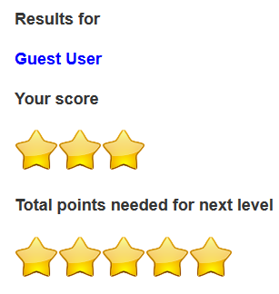
This now shows points needed for next level
Plain points replaced with a visual representation
Figure 11 - Fourth iteration of artefact with a visual representation of scores

Iteration 5

This iteration of the artefact contained only minor changes. The changes were to do with the styling of the artefact, namely how the end of level stars were displayed.

Iteration 6

This next iteration contained some major changes. It had been decided that the stars shown for the score and the stars shown for points needed for next level were somewhat confusing.

It was decided that this could be accomplished in one display. Therefore, the decision was made to have the full star for the points and the empty star to represent how many more they needed to fill.

It was intended to act as a progress bar.

The results from the quiz completion can be seen in figure 12

Changed to show actual and maximum score
Figure 12 - Sixth iteration of artefact showing score achieved and potential score

Iteration 7

This next iteration brought about major changes to the start page displayed to the user.

A focus group mentioned that instead of having just words on the page, it might be better to have an image to represent the shops.

Having taken this into consideration, a ‘busy’ picture of a street scene was added. It was decided to also add images representing the shops, to the main picture. These images were then made clickable. This would enable the user to scan the picture for the shop and click on the corresponding visual representation of the shop.

While a clickable picture was decided to be the best way to convey the representation, it was not decided what form this would take. HTML5 canvas and image mapping were both considered for use in this context.

HTML5 canvas is neater in that it allows the images to be placed as a layer over the main picture.

The idea of being able to use a single short line of code to overlay the main image, without the need to manipulate the original image via an external program, is considered as a bonus as the required HTML files would not be bulky and space consuming.

The major drawback with this approach is that is does not easily allow for images to be linked to, making them an interactive part of the artefact.

As the images are not clickable or interactive, it was decided that the images would be of no use to the artefact as they could not be used to enter the levels.

HTML5 canvas can only be considered a drawback as this interactivity cannot be achieved. It is a noted disappointment that HTML5 canvas cannot be used in the context of the artefact. It makes keeping the artefact to set web standards unachievable.

It was decided that image mapping would be better for this artefact. The code of the image mapping is very untidy. The clickable images and interactivity of the artefact come at the cost of untidy code and the separate images having to be pasted in via an external program.

The code needed for this to work requires that the image be mapped out with co-ordinates of the perimeter of the pasted in image. This in turn makes the link much longer than an ordinary anchored link in HTML.

It has been decided that this is a necessary step to take to ensure the interactivity of the artefact.

Another change was also made to the quiz completion page. There was not a way for the user to click through and find the next level without having to manually refresh the page.

A button was added that allowed the user to click to get back to the shops and choose the next level.

A message giving them a password was added to this page. Also, a message telling them the next shop they needed to visit was added.

These changes can be seen in figures 13 and 14.

User is able to click a visual representation of the shop
Figure 13 - Final iteration of artefact showing clickable image instead of buttons

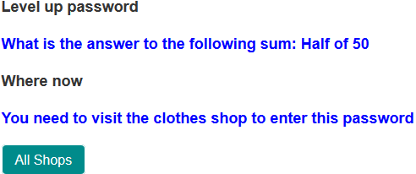
Figure 14 - Final iteration asking user to work out the password and then where they can enter it

The user can perform the equation to get the password
User is informed where to go next. Also, a way to get back to the main picture is provided

Results of Artefact Testing

The request to test the artefact was sent out to either parents of 7 – 9 year old children or those that were minders of children in this age range.

They were then asked to complete a survey so results could be gleaned from this. Unfortunately, the uptake on this survey was minimal at best. The survey was sent to around 20 people. Of this, only 20% have completed the survey.

Therefore, the results cannot be assumed as indicative of the whole audience and as such, the analysis of the results will not provide a true reflection

Analysis of Results

The results analysis here will be based upon results received from the survey. Again, the results are not indicative of the entire focus group.

This chart shows that randomly ordering questions is not something that is beneficial over ordered questions.

This chart shows that parent and minders disagreed with randomly ordered questions aiding in the learning process

This chart, interestingly, shows that parents and minders thought a list of buttons were less important and that a picture was more appropriate.

The answers from this question turned out to be somewhat surprising. The possible reason for this could be that pictures are seen to be more engrossing and attention capturing than a simple list of buttons.

Based on feedback from the previous chart where it was determined a picture was more appropriate than buttons, parents and minders thought that a busy picture would keep the children engrossed in the artefact. This chart below shows that representation.

When it came to feedback, the parents and minders were somewhat certain on what they wanted the artefact to do.

The following chart shows what they thought when it came to feedback after every question or feedback at the end of the quiz.

Another aspect the parents and minders were somewhat certain of, was that of a way to go back to the question and attempt it again after getting some feedback. The following chart shows this representation.

When it came to level progression and a password to get to the next level, the parents and minders were very certain about this aspect too. The following chart shows the responses.

When it came to providing the password on a sliding scale or providing it at 100%, the parents and minders were less certain. The following chart shows what they thought about this aspect of the artefact.

The parents and minders were asked which of the artefact versions they preferred and on this they were certain on which they preferred.

Based on the results of the question asking whether a list of buttons or a picture was a better representation, it appeared a surprise that one parent or minder preferred the artefact that was a list of buttons and ordered questions.

One possible reason for this, is that the particular child had a learning style that didn’t necessarily have to include any kind of visual representation. Another possible reason for this, could be that the child didn’t get to see the different versions of the artefact that was available.
The parents and minders were asked if there was any other feedback they wanted to provide and only 3 responses to this was received.

The responses that were received was “We think on the first artifact, that we did, we had two answers marked as wrong, but we think they were in fact right and the computer was wrong! from Jasmine and Joseph wade! But we did really enjoy it and wish they had this at our school :-)” (sic)

“The clothing picture needs to stand out a bit more. There should be some instructions to pick which store. Notice for more than one answer.”

“When there is an option for several right answers, it would be nice if you could put that.”

The feedback received from the final question will allow minor tweaks to the artefact to be made.

Conclusion

Success on initial objectives.

The project and artefact have followed the initial objectives quite well. Based on the results of the artefact testing, while not exhaustive, it would appear that the quiz, when used at home, helps with the learning of numeracy skills.

The project was able to determine all of the specific methods of learning numeracy taught in schools.

The project was only able to determine the methods taught in one local primary school. Therefore, it could not be considered exhaustive.

For the methods to be considered exhaustive, a representation of all the primary schools in the area would need to be undertaken. Due to the time constraints of the project, this was unable to be achieved. Since it was deemed an extremely important aspect of the project, it was therefore considered acceptable that only one school was contacted.

The project was unable to determine one way or another, with regards to shapes and colours, which was more important. The only aspect the project was able to determine, involving shapes and colours, was from what parents and minders felt themselves. A colour blind learner was not identified, thus not enabling this aspect to be explored in more detail.

What did or did not go well?

During the course of the project, the gathering of data from focus group surveys proved to be very challenging.

This could be down to time constraints of the parents and minders. It could be down to lack of motivation from parents, minders and children.

There are a number of reasons why the uptake of the surveys was poor. It would be wrong to speculate an exact reason for this.

The design and building of the artefact went extremely well. Once information had been gleaned on what was important to include, it turned out to be the easiest part of the project. It can be considered a huge success.

A factor in the success is that information was gleaned early on, allowing the building to start as early as possible.

The researching required for the project proved to be a challenge at times. Because this type of artefact is fairly new to the learning scene, there is very little data available.

The data that was available proved to be invaluable to the project.

Tools used

For the artefact section of the project, the tools that were used to create it were as follows:

- Notepad++ Text Editor
- Firefox, Chrome and Internet Explorer web browsers
- Apache web server

All of the aforementioned tools would be used again to recreate this artefact. Notepad++ provides a way to edit the files and does it in a way that is easy to understand. This helps should any code not be properly closed or is missing any of the required syntax.

As the artefact is provided via a web browser, it would be foolish to think these tools would not be needed in a recreation of the artefact.

Apache web server would be the only tool that would not be needed to recreate the artefact. The reason for this, is that web pages do not provide any information that needs to be retrieved from a database. It also does not require pages to be compiled by a server to make them perform as they should.

Achievements

The project provided a way to learn new skills. Based on the artefact and the results from research, these can be deemed a success.

The skills learned during the project are in line with the initial learning that was intended at the commencement of the project.

Future developments

If the artefact is to be developed further, the following considerations have been put into place to enable a starting point for that to happen:

Drag and drop questions

Instead of having just image or text based questions, it is important to have some human-computer interaction. This can be in the form of drag and drop questions. The idea for this is that there will be a question and instead of checkboxes or radios, there will be images of coins that can be dragged to an image of a till. This will then provide some instant feedback to the user.

Certificate of completion

The idea behind this comes from speaking with educators at a local school. The teacher stated that it was important for the children to have some kind of reward system that will help encourage them to continue on in the game. A level completion certificate was deemed to be the best way to present this. This can be incorporated at the end of a level. It is anticipated that when a certain threshold is reached, a link to a certificate will be presented in which the user can then download and print off for their own records.

Image maps

The idea behind the image maps is to create a clickable image that will allow the user to select parts of the picture as the answer. The clickable part can then be used to present further questions or rewards. This can be incorporated through the use of HTML and jQuery.

Login system

A login system can be incorporated to make use of storing user data and progress enabling the user to carry on from where they have left off. It can be used to see how well they are doing in the game. This will be incorporated through the use of MySQL and PHP. It is anticipated that this will be hosted on an external website or a school network. It will require someone who has knowledge of MySQL and PHP to administer this.

Staggered star progression

The idea behind this suggestion is that, depending on the level number, a minimum threshold would be required to be able to advance to the next level. This would be – as a suggestion only – 50% correct for level 1, all the way to 100% correct for level 5.

Sounds as feedback

It has been shown that children respond well to sound. The idea is to have audio feedback at the end of each question. This can be a ‘well done’ or a clapping noise for a right answer or an ‘uh-oh’ or buzzer sound for a wrong answer. You could also have a ‘try again’ sound for a wrong answer.

Question Banks

Another aspect that can be included in future development is that of a question bank. A question bank enables a wide range of questions to be stored. This question bank will provide tailored questions to the user depending on the skill and level they have shown during the game. If a user gets a particular question wrong, the question bank will provide the user with more of the same so that they can work on getting these types of questions right to progress further in the game.

Appendix 1 – Initial Gantt Chart
Task Name | Duration | Start | Finish
Artefact Prototype Start | 1 day | Mon 28/01/13 | Mon 28/01/13
Project Hand In | 1 day | Fri 03/05/13 | Fri 03/05/13
Draft Project Proposal | 1 day | Mon 01/10/12 | Mon 01/10/12
Initial Supervisor Meeting | 1 day | Thu 18/10/12 | Thu 18/10/12
Interview with local school teacher | 1 day | Wed 24/10/12 | Wed 24/10/12
CV, Ethics, PID, Exit Plan due | 1 day | Fri 09/11/12 | Fri 09/11/12
Supervisor Meeting | 1 day | Thu 15/11/12 | Thu 15/11/12
Poster Session (Preliminary) | 1 day | Fri 17/05/13 | Fri 17/05/13
Decide on Project | 5 days | Mon 24/09/12 | Fri 28/09/12
Research on how children learn | 5 days | Mon 01/10/12 | Fri 05/10/12
Research on what games are out there | 5 days | Mon 01/10/12 | Fri 05/10/12
Supervisor Meeting | 1 day | Wed 23/01/13 | Wed 23/01/13
Supervisor Meeting | 1 day | Fri 08/02/13 | Fri 08/02/13
Supervisor Meeting | 1 day | Fri 22/02/13 | Fri 22/02/13
Supervisor Meeting | 1 day | Mon 04/03/13 | Mon 04/03/13
Supervisor Meeting | 1 day | Fri 22/03/13 | Fri 22/03/13
Supervisor Meeting | 1 day | Mon 25/03/13 | Mon 25/03/13
Distribute Questionnaire | 1 day | Mon 04/03/13 | Mon 04/03/13
Artefact Testing | 14 days | Mon 04/03/13 | Thu 21/03/13
Artefact Testing Questionnaire | 1 day | Fri 29/03/13 | Fri 29/03/13
Research into Feedback | 5 days | Thu 10/01/13 | Wed 16/01/13
Update report with information from feedback research | 1 day | Thu 17/01/13 | Thu 17/01/13
Research into HCI | 5 days | Fri 18/01/13 | Thu 24/01/13
Update report with information from HCI research | 1 day | Fri 25/01/13 | Fri 25/01/13
Document artefact prototyping | 3 days | Fri 01/02/13 | Tue 05/02/13
Document artefact testing | 3 days | Wed 06/02/13 | Fri 08/02/13
Document results from testing questionnaire | 3 days | Mon 11/02/13 | Wed 13/02/13
Prepare draft poster | 1 day | Mon 01/04/13 | Mon 01/04/13
Prepare full poster | 1 day | Wed 01/05/13 | Wed 01/05/13
End Prototyping | 1 day | Fri 01/03/13 | Fri 01/03/13
Prototype 1 | 1 day | Fri 01/02/13 | Fri 01/02/13
Prototype 2 | 1 day | Mon 04/02/13 | Mon 04/02/13
Prototype 3 | 3 days | Tue 05/02/13 | Thu 07/02/13
Prototype 4 | 2 days | Fri 08/02/13 | Mon 11/02/13
Focus Group 1 | 1 day | Thu 14/02/13 | Thu 14/02/13
Prototype 5 | 2 days | Mon 18/02/13 | Tue 19/02/13
Focus Group 2 | 1 day | Tue 19/02/13 | Tue 19/02/13
Prototype 6 | 2 days | Wed 20/02/13 | Thu 21/02/13
Prototype 7 | 1 day | Mon 25/02/13 | Mon 25/02/13
Write report | 20 days | Tue 02/04/13 | Mon 29/04/13
Supervisor Meeting | 1 day | Fri 19/04/13 | Fri 19/04/13
Supervisor Meeting | 1 day | Fri 26/04/13 | Fri 26/04/13

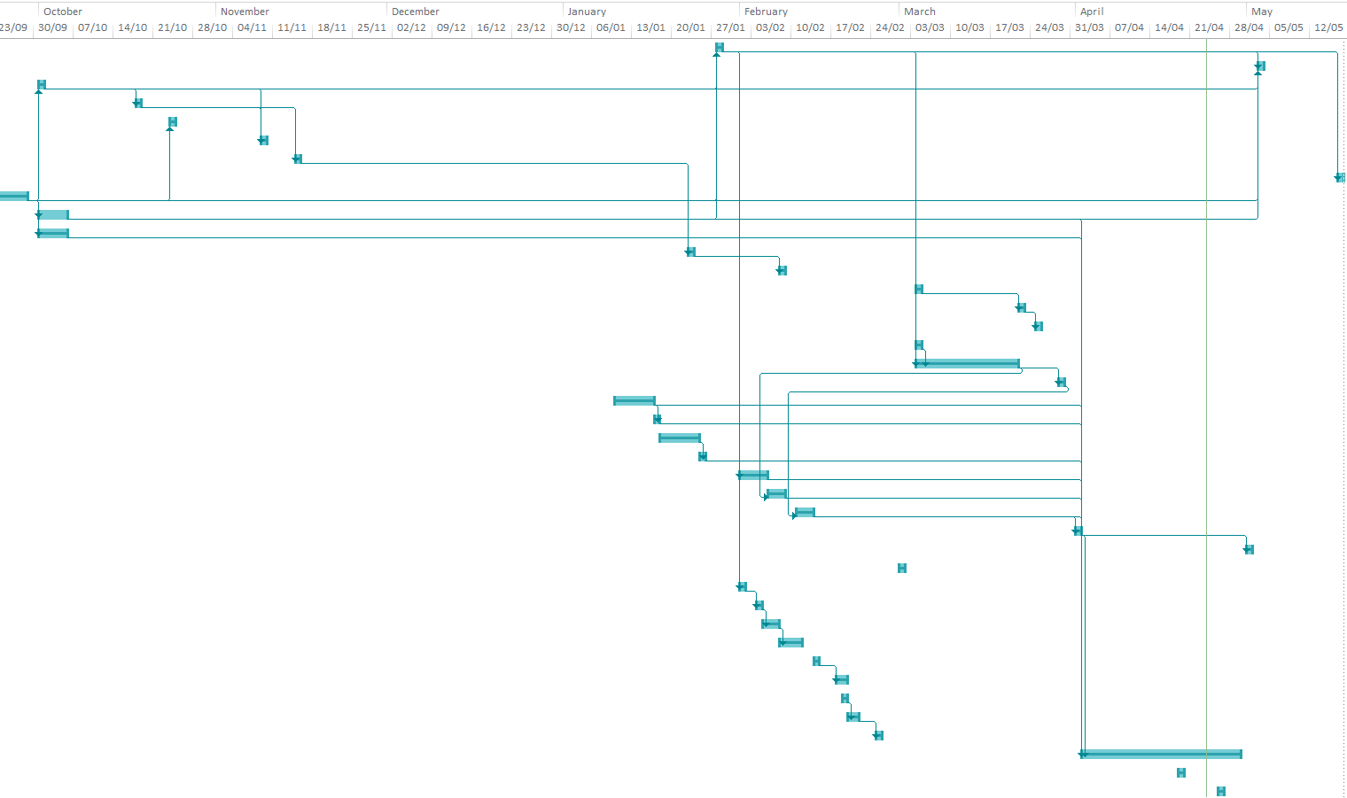

Appendix 2 – Actual Gantt Chart

Task Name | Duration | Actual Start | Actual Finish
Artefact Prototype (Preliminary) | 1 day | Mon 28/01/13 | Mon 28/01/13
Project Hand In | 1 day | Fri 03/05/13 | Fri 03/05/13
Draft Project Proposal | 1 day | Mon 01/10/12 | Mon 01/10/12
Initial Supervisor Meeting | 1 day | Thu 18/10/12 | Thu 18/10/12
Interview with local school teacher | 1 day | Wed 24/10/12 | Wed 24/10/12
CV, Ethics, PID, Exit Plan due | 1 day | Fri 09/11/12 | Fri 09/11/12
Supervisor Meeting | 1 day | Thu 15/11/12 | Thu 15/11/12
Poster Session (Preliminary) | 1 day | Fri 17/05/13 | Fri 17/05/13
Decide on Project | 5 days | Mon 24/09/12 | Fri 28/09/12
Research on how children learn | 5 days | Wed 03/10/12 | Tue 09/10/12
Research on what games are out there | 5 days | Wed 10/10/12 | Tue 16/10/12
Supervisor Meeting | 1 day | Wed 23/01/13 | Wed 23/01/13
Supervisor Meeting | 1 day | Fri 08/02/13 | Fri 08/02/13
Supervisor Meeting | 1 day | Mon 04/03/13 | Mon 04/03/13
Supervisor Meeting | 1 day | Fri 22/03/13 | Fri 22/03/13
Supervisor Meeting | 1 day | Mon 25/03/13 | Mon 25/03/13
Distribute Questionnaire | 1 day | Wed 06/03/13 | Wed 06/03/13
Artefact Testing | 14 days | Mon 04/03/13 | Thu 21/03/13
Artefact Testing Questionnaire | 1 day | Mon 25/03/13 | Mon 25/03/13
Research into Feedback | 5 days | Thu 10/01/13 | Wed 16/01/13
Update report with information from feedback research | 1 day | Thu 17/01/13 | Thu 17/01/13
Research into HCI | 5 days | Sun 20/01/13 | Thu 24/01/13
Update report with information from HCI research | 1 day | Sun 27/01/13 | Sun 27/01/13
Document artefact prototyping | 3 days | Fri 01/02/13 | Tue 05/02/13
Document artefact testing | 3 days | Wed 06/02/13 | Fri 08/02/13
Document results from testing questionnaire | 3 days | Mon 11/02/13 | Wed 13/02/13
Prepare draft poster | 1 day | Mon 01/04/13 | Mon 01/04/13
Prepare full poster | 1 day | Wed 01/05/13 | Wed 01/05/13
End Prototyping | 1 day | Fri 01/03/13 | Fri 01/03/13
Prototype 1 | 1 day | Fri 01/02/13 | Fri 01/02/13
Prototype 2 | 1 day | Mon 04/02/13 | Mon 04/02/13
Prototype 3 | 3 days | Tue 05/02/13 | Thu 07/02/13
Prototype 4 | 2 days | Fri 08/02/13 | Mon 11/02/13
Focus Group 1 | 1 day | Thu 14/02/13 | Thu 14/02/13
Prototype 5 | 2 days | Mon 18/02/13 | Tue 19/02/13
Focus Group 2 | 1 day | Tue 19/02/13 | Tue 19/02/13
Prototype 6 | 2 days | Wed 20/02/13 | Thu 21/02/13
Prototype 7 | 1 day | Mon 25/02/13 | Mon 25/02/13
Write report | 18 days | Tue 02/04/13 | Thu 25/04/13
Supervisor Meeting | 1 day | Fri 19/04/13 | Fri 19/04/13
Supervisor Meeting | 1 day | Fri 26/04/13 | Fri 26/04/13

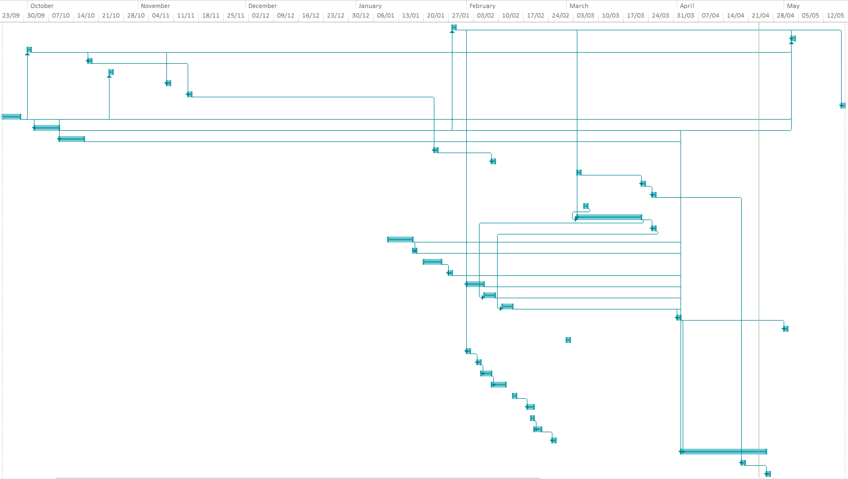

Appendix 3 – Interview with Primary School Teacher

MINUTES OF MEETING

Date: Wednesday October 24, 2012
Time: 13:50
Place: Burrowmoor Primary School (BPS)
Present: Jo Mills (JM)
Carrie Henderson (CH)
1068664

NUMERACY

1068664 asked JM what the current National Curriculum (NC) guidelines were for times tables in the Key Stage (KS) 1 and KS2 stages were.

It was established, for the purpose of the dissertation, that:

- 6 - 7 year olds were Year 2 children,
- 7 - 8 year olds were Year 3 children,
- 8 - 9 year olds were Year 4 children,
- Years 2 and 3 were in the KS1 group,
- Year 4 children were in the KS2 group

JM stated that at present, children learn up to 10 x 10 at KS2 level. JM stated that there was a proposal to change this to 12 x 12.

JM stated that times tables needed repeated practice for the learning to be effective.

JM stated that children need to not only know their numbers, but also how to use them.

JM stated that the children should know the following times tables, along with the corresponding divisions:

- Year 3:
  - 2, 3, 4, 5, 6, 10
- Year 4:
  - Up to 10 x 10 (With a draft proposal of 12 x 12, possibly from 09/13)

JM stated that the market for numeracy games – in particular for times tables – was already saturated.

JM stated that it was left up to the individual schools how the times tables were taught and that there is no definitive guidance on how they should be taught.

JM stated that Woodlands Junior School, Kent had a wealth of web pages for numeracy games and that this would be beneficial to check out to see what they have.
REWARDS

JM stated that within BPS, various methods of rewards had been tried to encourage the children to learn the times tables. Various methods included the following (but this is not an exhaustive list):

- Stickers
- Stars

METHODS OF LEARNING

JM stated that weekly tests were also trialled to see if this would help the children with the learning of their times tables.

JM also stated that multiplication grids had been used, but that the children did not learn best from these.
JM stated that the children need to apply the knowledge of the times tables for the learning to be effective.

JM stated that the involvement of a parent is integral to the learning of the child, and that parents need to help the child know and apply this knowledge.

1068664 stated that an idea for the dissertation would be to put it into a real world scenario and the example that was used was “You and 2 friends go to get the bus to school and the fare is 5p each. How much would you need to give the driver so the fare is correct?”

JM stated that it would be important for the child to apply this knowledge in a real life context. However, this example would include problem solving and not all children would be knowledgeable enough to do this.

1068664 stated that the game would be such that an advanced child would be able to do the questions without help, and that a parent would be required to help a child that isn’t as advanced in their times tables.

JM stated that hands with the times tables on them had been used. The children would be given the hand with the correct answer on, and it would be a case of lifting up the finger to see if the answer is correct. The example was that the 4 times table would be used and if the child wanted to know what 4 x 4 is, they would count 4, 8, 12, 16 and then lift the finger to see if this is correct.

TIME TO LEARN

JM stated that Years 5+ were given as little as 10 minutes a week to go over times tables and that Years 4 were given what time was needed.

OTHER

JM stated that the NC is broken down into KS. JM also stated that the Framework is broken down into Year Groups.

CH stated that a visual representation of numbers would be something to look into as they have used that in BPS to help with the learning. An example that CH used was that a certain number represents a certain shape and that the number 4 represents a cake as it is square.

Both JM and CH suggested that Teach Find was something worth looking into. These are documents that were used under the last government that appeared to work. It was suggested to search for Teach Find ITP – 2000 – Array to see the visual representation in action.

Appendix 4 – Artefact Design Questionnaire

- How old is your child?

7 8 9

- Do you think technology can play a role in education outside of school?

Strongly Agree Agree Disagree Strongly Disagree

- On a scale of 1 – 10, how important is numeracy?

1 2 3 4 5 6 7 8 9 10

- Do you feel a game would help your child learn numeracy?

Strongly Agree Agree Disagree Strongly Disagree

- Do you feel the game should follow national curriculum targets?

Strongly Agree Agree Disagree Strongly Disagree

- Can your child do arithmetic?

Please present your child with the following sums; ask them to attempt them without help from yourself or a calculator. Record their answers in the boxes.

6 x 5 =  20 – 13 =   + 33 = 100 45 /  = 9

- Thinking about times tables, what is the highest table your child can do?

1 2 3 4 5 6 7 8 9 10 11 12

- Think about the highest times table your child can do, can they do it without help?

Yes No

- At which times table do they start to need to use help?

1 2 3 4 5 6 7 8 9 10 11 12

- Do you think shapes and colours are important in a game to help with numeracy?

Strongly Agree Agree Disagree Strongly Disagree

- Which do you feel is more important?

Colours Shapes Both Equal

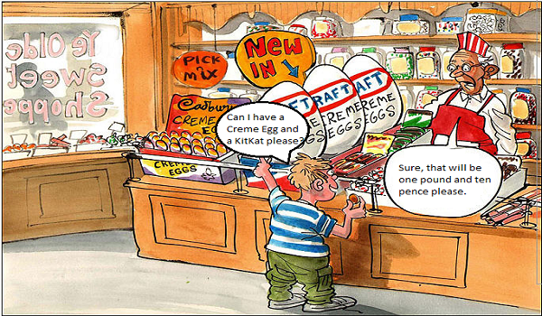
Please look at the image below. Then answer the questions following. The idea is that the child will then be able to determine the right amount of change they should receive after handing over £2 (Two pounds)

- Do you think images are important to help convey an arithmetic problem?

Strongly Agree Agree Disagree Strongly Disagree

- Think about the above scenario recorded as a video, do you feel this is important to help convey an arithmetic problem?

Strongly Agree Agree Disagree Strongly Disagree

Can you have your child look at the picture, and then have them determine how much change should be received from £2 (Two pounds)

- What is the answer your child came up with?

_______________
- Was your child able to do this sum without any help from another person or a calculator?

Yes No

- If your child needed help, what source did they use for help?

Another Person Calculator

Thank you for taking the time to complete the questionnaire. Your results will help shape the outcome of the artefact that is being produced. If you have any more comments, please add them to this document or in your email.

Many Thanks.

Appendix 5 – Artefact Design Questionnaire Results

Q1. How old is your child?
7 | 4
8 | 2
9 | 5
Total | 11

Q2. Do you think technology can play a role in education outside of school?
Strongly Agree | 5
Agree | 3
Disagree | 0
Strongly Disagree | 2
Total | 10

Q3. On a scale of 1 - 10, how important is numeracy?

1 | 0
2 | 0
3 | 0
4 | 0
5 | 0
6 | 0
7 | 0
8 | 3
9 | 2
10 | 4
Total | 9
Q4. Do you feel a game would help your child learn numeracy?

Strongly Agree | 5
Agree | 2
Disagree | 1
Strongly Disagree | 1
Total | 9

Q5. Do you feel the game should follow national curriculum targets and guidelines?
Strongly Agree | 6
Agree | 1
Disagree | 1
Strongly Disagree | 1
Total | 9
Q6. For this question, I want to know if your child can do arithmetic. Please present your child with the following sums; ask them to attempt them without help from yourself or a calculator. Record their answers here

6 x 5 = ? | 5
20 - 13 = ? | 5
? + 33 = 100 | 5
45 / ? = 9 | 5
Total Respondents: 5

Q7. Thinking about times tables, what is the highest table your child can do?

1 | 0
2 | 0
3 | 1
4 | 0
5 | 0
6 | 1
7 | 0
8 | 0
9 | 0
10 | 1
11 | 0
12 | 2
Total | 5
Q8. Thinking about the highest table your child can do, can they do it without help?

Yes | 4
No | 1
Total | 5

Q9. At which times table do they start to need help?

1 | 0
2 | 0
3 | 0
4 | 2
5 | 0
6 | 0
7 | 3
8 | 0
9 | 0
10 | 0
11 | 0
12 | 0
Total | 5
Q10. Do you think shapes and colours are important in a game to help with numeracy?

Strongly Agree 0
Agree 3
Disagree 0
Strongly Disagree 0
Total 3

Q11. Which do you feel is more important?

Colours 0
Shapes 1
Both Equal 2
Total 3
Q12. Could you have your child look at the picture and explain it to them and then ask them how much change should be given from £2 (Two Pounds)

0.90
90p
90

Q13. Was your child able to do this sum without any help?

Yes 1
No 2
Total 3

Q14. If your child needed help, what source did they use for help?

Another Person 3
Calculator 0
Total 3

Q15. Do you think images are important to help convey an arithmetic problem?

Strongly Agree 1
Agree 2
Disagree 0
Strongly Disagree 0
Total 3

Q16. Thinking about the picture recorded as a video. Do you feel this is important to help convey an arithmetic problem?

Strongly Agree 0
Agree 3
Disagree 0
Strongly Disagree 0
Total 3

If there is anything else you wish to add, please use this box to add anything else.
0 responses

Appendix 6 – Artefact Testing Questionnaire

1. Thinking specifically of the questions, do you think randomly ordered questions - such as those in artefact 2 and artefact 3 - are better than ordered questions?

Strongly Agree
Agree
Disagree
Strongly Disagree

2. Do you feel randomly ordered answers better aid in the learning process?

Strongly Agree
Agree
Disagree
Strongly Disagree

3. Thinking specifically of the opening page, do you think a list of buttons is more appropriate than a clickable picture of the shops?

Strongly Agree
Agree
Disagree
Strongly Disagree

4. Thinking specifically of the picture in artefact 3, do you feel that a busy picture like that would keep your child more engrossed in the quiz?

Yes
No
Please state your reasons for your choice
5. Thinking specifically of the feedback, do you think feedback after every question is more appropriate than feedback at the end of the quiz?

Strongly Agree
Agree
Disagree
Strongly Disagree

6. Do you think a 'Go Back' button would be useful to help aid the learning?

Yes
No

7. Thinking specifically of the end of the quiz, do you feel that working out the password is better than just giving the password?

Strongly Agree
Agree
Disagree
Strongly Disagree

8. Do you feel that level password and progression should only happen at 100% or should it be on a sliding scale?

E.g.: Level 1 - get at least 20% and the password will be shown. Level 2 - get at least 40%, all the way to level 5 and getting 100%

Only at 100%
Sliding Scale

9. Which quiz did you prefer?

1 - Ordered Questions
2 - Feedback after every question
3 - Picture of shops

10. And finally... Do you have any other comments you feel should be taken on board in respect of the artefacts

Appendix 7 – Wireframes
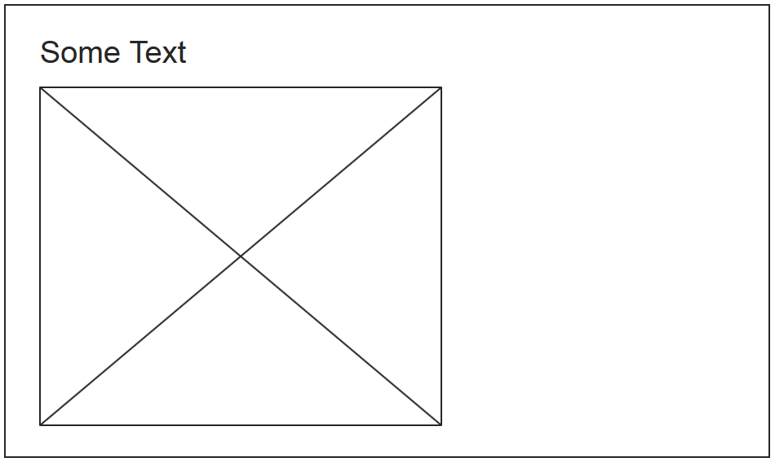
This is a representation of the main page that the user will see upon opening the artefact
Upon opening the artefact, the user will be requested to input a name and then click on proceed
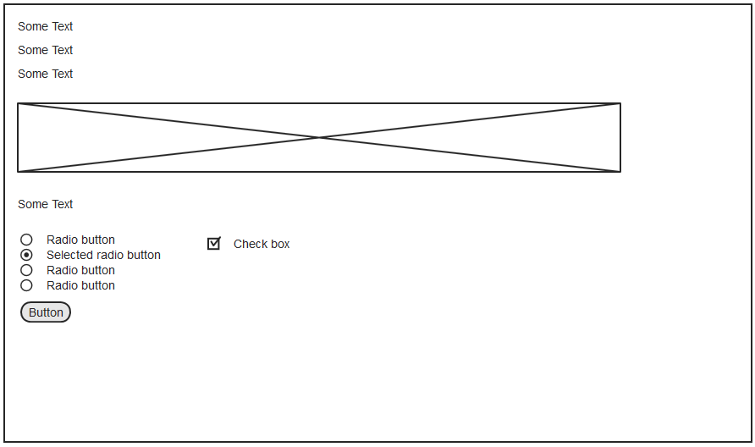
This is a representation of a question the user will see.
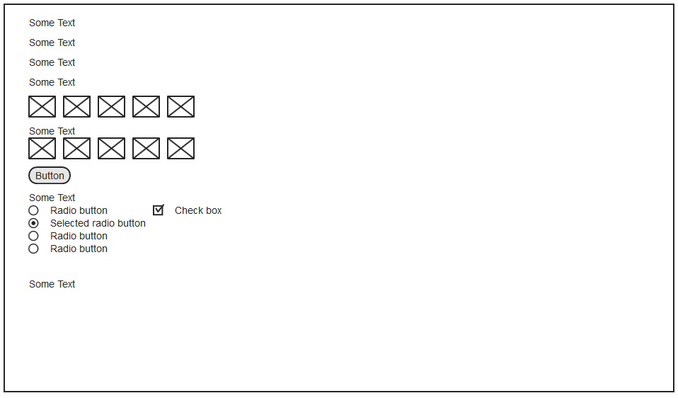
This is a representation of the results page the user will see.

Appendix 8 – Minutes of Supervisor Meetings
18 October 2012
This was the initial meeting with supervisors.
Discussed were methodologies, type of artefact and to look at key experts in each of the fields the project will cover.
Also discussed was determining if the project was feasible, who the project was aimed at.
The main things to get ready for the next meeting are:
- Literature Review
- Methodology
- Feasibility of project
- Initial Gantt Chart
- PID
15 November 2012
This meeting was to check on the progress of the literature review, methodology and feasibility.
It was suggested to break project research down into smaller chunks so that effective research could be carried out.
The main things to get ready for the next meeting are:
- Updated Gantt
- Restructured Questionnaire
- Commencement of Prototyping
- Continuation of Literature Review
23 January 2013
This meeting was to check on the progress of the Gantt chart, questionnaire and prototyping. It was determined that prototyping had been started and was going well.
The main things to get ready for the next meeting are:
- Update on research
- Continuation of prototyping

08 February 2013
This meeting was to check on the progress of the research and prototyping. It was determined that both of these were going well and to plan.
The main things to get ready for the next meeting are:
- Update on prototyping
- Update on research
- Commencement of report writing
04 March 2013
The main purpose of this meeting was to check on the progress of the report and to see if it had been started. It was also to check on issues with prototyping and writing the report. Also talked about was starting to think about testing of the artefact and setting up focus groups.
This meeting also talked about adding features to the artefact such as sounds, progress bars and visual representations of how well the user has done. It was also mentioned that feedback to the user is very important.
The main things to get ready for the next meeting are:
- Continuation of the prototype and trying to add in suggested features
- Continuation of research
- Continuation of report writing
22 March 2013
This meeting was scheduled to check on the progress of the artefact and more importantly the research and report writing. It was mentioned that the features that were recommended had been implemented with the exclusion of sounds. It was stated that sounds could be added as a future development
The writing of the report and researching was deemed to be going really well.
The main things to get ready for the next meeting are:
- Concluding prototyping
- Continuation of research
- Continuation of report writing

25 March 2013
This meeting was scheduled to mainly check on the progress of the research and report. It was stated that prototyping had ceased and that testing had commenced on the prototype. It was also stated that research was nearing its conclusion and that efforts were being focussed on the writing of the report.
The main things to prepare for the next meeting are:
- Making sure testing is complete
- Making sure research is being documented and entered into the report
- Make sure report writing is on track
19 April 2013
The main purpose of this meeting was to determine that testing was in fact completed. It was also to check on the status of the report. It was stated that the testing had been completed and that results were being gathered.
It was also stated that the report writing is nearing its conclusion and that the final bits of research and results were being added to it.
The purpose of the meeting on 26 April 2013 is to make sure that the report is complete
26 April 2013
This was determined to be the final meeting before the submission of the report. It was determined that all report writing had concluded and that a draft poster had been completed with a view to preparing the final poster in time for the poster session on 17 May 2013

Appendix 9 - Poster
PROJECT TITLE
CHARTS FROM SURVEY
CHARTS FROM SURVEY
FEEDBACK FROM ARTEFACT TEST SURVEY
LEARNING AIMS
IMAGE FROM FRONT PAGE OF ARTEFACT

Bibliography
Anon., 2003. Methodology:: Development Models. [Online]
Available at: http://myprojects.kostigoff.net/methodology/development_models/development_models.htm#evolutionary
[Accessed 17 03 2013].
Anon., 2007. Advantages of the Spiral Model. [Online]
Available at: http://www.sqa.org.uk/e-learning/SDM01CD/page_10.htm
[Accessed 20 04 2013].
Anon., 2007. JSON vs. XML: The Debate - Ajaxian. [Online]
Available at: http://ajaxian.com/archives/json-vs-xml-the-debate
[Accessed 17 03 2013].
Anon., n.d. eLearner - Advantages and Disadvantages. [Online]
Available at: http://www.dso.iastate.edu/asc/academic/elearner/advantage.html
[Accessed 17 04 2013].
Anon., n.d. e-learning | the benefits of e-learning. [Online]
Available at: http://www.embrace-learning.co.uk/Website/Pages/Guest/benefits.php
[Accessed 17 04 2013].
Anon., n.d. Gamification Wiki | Gamification Wiki. [Online]
Available at: http://www.gamification.org/
[Accessed 21 03 2013].
Anon., n.d. Schneiderman's "Eight Golden Rules of Interface Design". [Online]
Available at: http://faculty.washington.edu/jtenenbg/courses/360/f04/sessions/schneidermanGoldenRules.html
[Accessed 02 04 2013].
Anon., n.d. Spiral Development | QMetry. [Online]
Available at: http://www.qmetry.com/spiral.html
[Accessed 20 04 2013].
Bodreaux, R., 2012. HTML5 vs. Flash: The state of the debate | TechRepublic. [Online]
Available at: http://www.techrepublic.com/blog/webmaster/html5-vs-flash-the-state-of-the-debate/1556
[Accessed 17 03 2013].
Bray, T., 2006. ongoing by Tim Bray - JSON and XML. [Online]
Available at: http://www.tbray.org/ongoing/When/200x/2006/12/21/JSON
[Accessed 17 03 2013].
Casale, C., 2012. HTML5 vs. Flash - What Do You Need To Know? Part 1. [Online]
Available at: http://blog.accusoft.com/posts/2012/october/html5-vs-flash-what-do-you-need-to-know-part-1.html
[Accessed 17 03 2013].
Department for Education Schools, 2011. Mathematics - Schools. [Online]
Available at: http://www.education.gov.uk/schools/teachingandlearning/curriculum/primary/b00199044/mathematics
[Accessed 17 03 2013].
Dunham, T. & Sindhvad, S., 2005. [Online]
Available at: http://www.uwex.edu/disted/conference/Resource_library/proceedings/03_41.pdf
[Accessed 17 03 2013].
Freid, 2011. A messy city. [Art].
Gabai, A., 2009. Creating a basic memory game with jQuery and php | Webdev Playground. [Online]
Available at: http://www.webdevplayground.com/2009/09/a-basic-memory-game-with-jquery-and-php/
[Accessed 17 03 2013].
JISC, n.d. JISC - Starting point. [Online]
Available at: http://www.elearning.ac.uk/effprac/html/start_defin.htm
[Accessed 17 03 2013].
Larman, C. & Basili, V., 2003. Iterative and incremental developments. a brief history. Computer, 36(6), pp. 47-56.
Marinescu, F. & Tilkov, S., 2006. Debate: JSON vs. XML as a data interchange format. [Online]
Available at: http://www.infoq.com/news/2006/12/json-vs-xml-debate
[Accessed 17 03 2013].
metajack, 2010. JSON versus XML: Not as Simple as You Think. [Online]
Available at: http://metajack.im/2010/02/01/json-versus-xml-not-as-simple-as-you-think/
[Accessed 17 03 2013].
mythz, 2010. History of REST, SOAP, POX and JSON Web Services - Tales from behind the browser. [Online]
Available at: http://www.servicestack.net/mythz_blog/?p=154
[Accessed 17 03 2013].
Nielsen, J., 2012. Usability 101: Introduction to Usability. [Online]
Available at: http://www.nngroup.com/articles/usability-101-introduction-to-usability/
[Accessed 02 04 2013].
Petty, G., 2004. Geoff Petty - Teaching Today - Feedback. [Online]
Available at: http://geoffpetty.com/feedback.html
[Accessed 17 03 2013].
Sandhofer, C. M. & Smith, L. B., 1999. Learning Color Words Involves Learning a System of Mappings. Developmental Psychology, 35(3), pp. 668-679.
The Learning Management Corporation, n.d. [Online]
Available at: http://www.thelearningmanager.com/pubdownloads/writing_effective_questions.pdf
[Accessed 17 03 2013].
The Smart Method Ltd, 2011. Waterfall Development Methodology. [Online]
Available at: http://www.learnaccessvba.com/application_development/waterfall_method.htm
[Accessed 20 04 2013].
Virvou, M., Katsionis, G. & Manos, K., n.d. Combining Software Games with Education: Evaluation of its Educational Effectiveness. Educational Technology & Society, 8(2), pp. 54-65.
w3schools, n.d. HTML5 Canvas. [Online]
Available at: http://www.w3schools.com/html/html5_canvas.asp
[Accessed 23 03 2013].

References
Casale, C., 2012. HTML5 vs. Flash - What Do You Need To Know? Part 1. [Online]
Available at: http://blog.accusoft.com/posts/2012/october/html5-vs-flash-what-do-you-need-to-know-part-1.html
[Accessed 17 03 2013].
JISC, n.d. JISC - Starting point. [Online]
Available at: http://www.elearning.ac.uk/effprac/html/start_defin.htm
[Accessed 17 03 2013].
Marinescu, F. & Tilkov, S., 2006. Debate: JSON vs. XML as a data interchange format. [Online]
Available at: http://www.infoq.com/news/2006/12/json-vs-xml-debate
[Accessed 17 03 2013].
metajack, 2010. JSON versus XML: Not as Simple as You Think. [Online]
Available at: http://metajack.im/2010/02/01/json-versus-xml-not-as-simple-as-you-think/
[Accessed 17 03 2013].
Nielsen, J., 2012. Usability 101: Introduction to Usability. [Online]
Available at: http://www.nngroup.com/articles/usability-101-introduction-to-usability/
[Accessed 02 04 2013].
Petty, G., 2004. Geoff Petty - Teaching Today - Feedback. [Online]
Available at: http://geoffpetty.com/feedback.html
[Accessed 17 03 2013].

